Lesson 4 Demo 5: Building Projects with Gradle

This section will guide you to:

* Build projects with Gradle in jenkins

This lab has three sub-sections, namely:

1. Configuring Gradle plugin for Jenkins

2. Creating a Gradle project

3. Building a project with Gradle in Jenkins

**Please Note**: Gradle plugin is installed by default. In case you don’t have it installed, you can install the same by following the step 1.

**Step 1:** Configuring Gradle plugin for Jenkins

* Go to Jenkins dashboard.
* Click on ***Manage Jenkins*** and select ***Manage Plugins***.

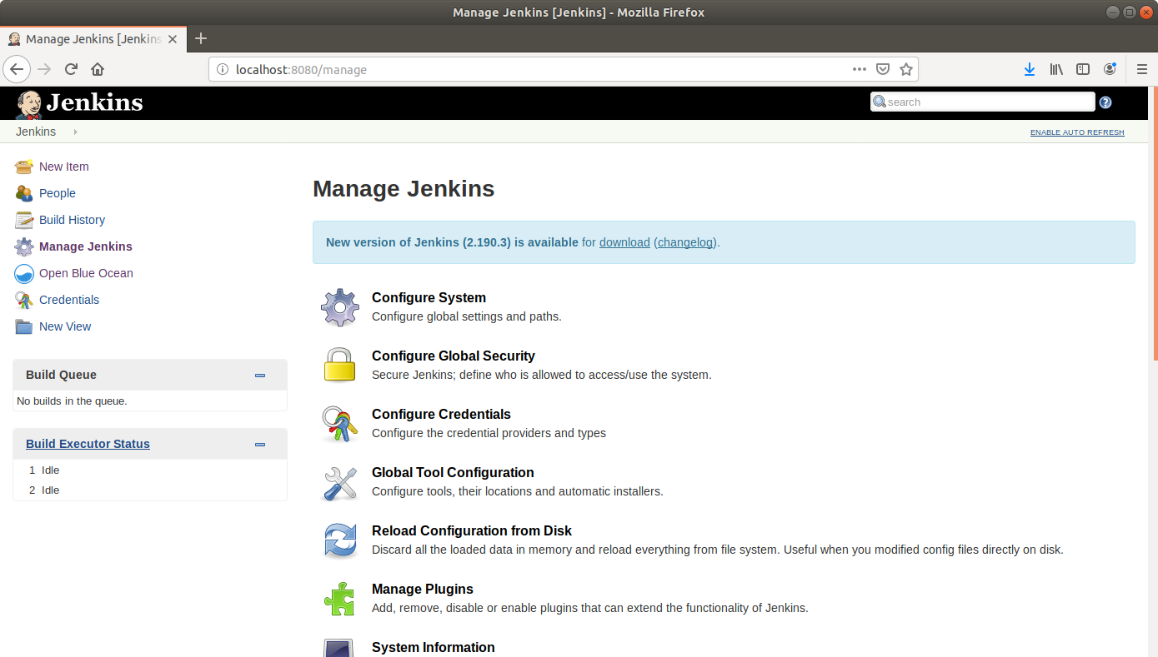

* Under the ***Available*** tab, select ***Gradle***.

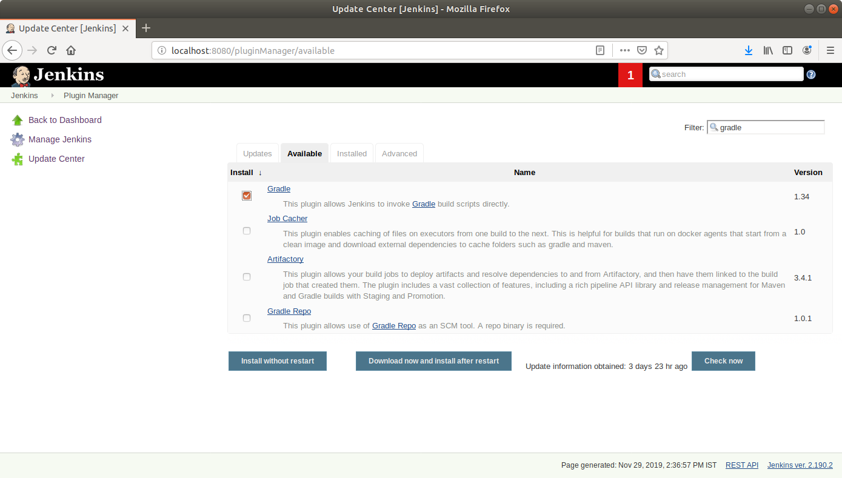

* Click on ***Install without restart*** and the plugin will be installed.

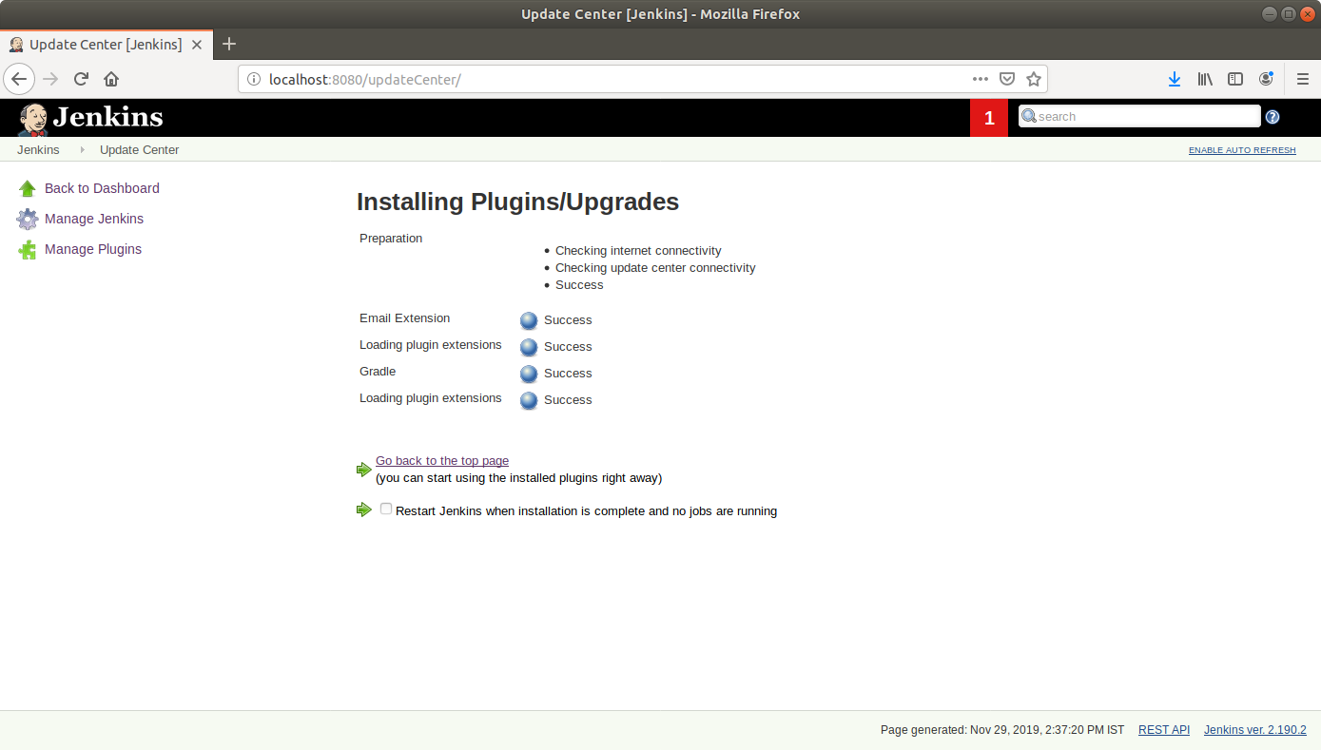

* Click on ***Manage Jenkins***and select ***Global Tool Configuration****.*
* Scroll down to the ***Gradle*** section and click on ***Add Gradle***.

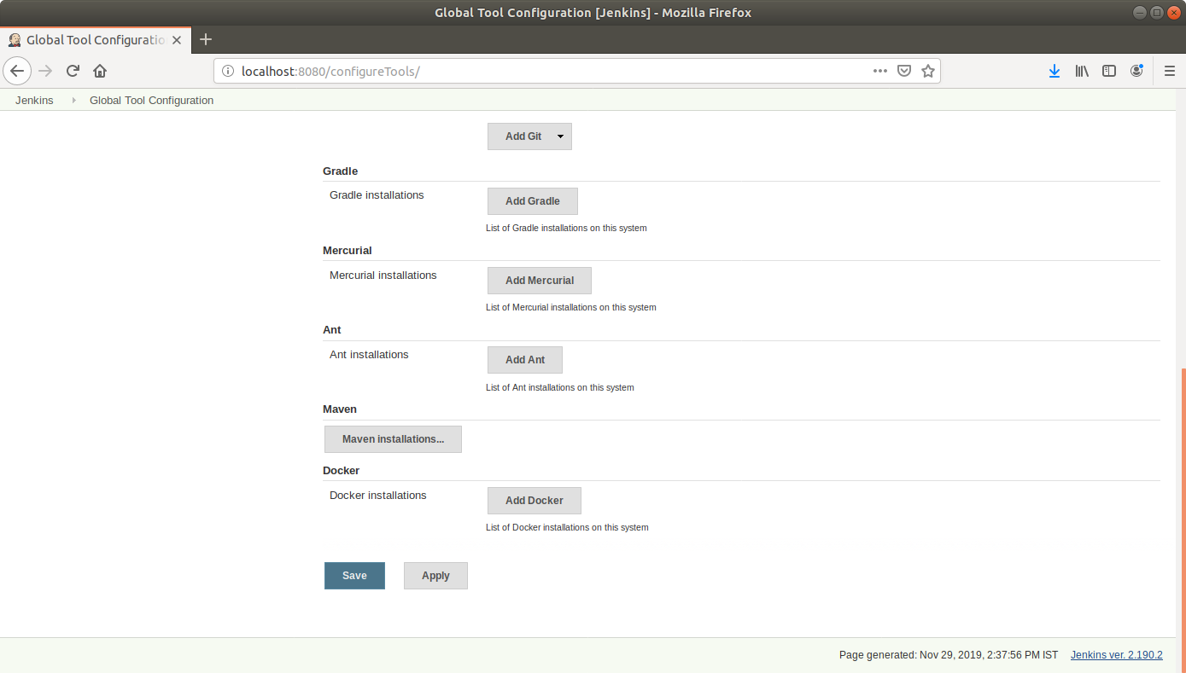

* Check the ***Install automatically*** box and specify a name for the installation.

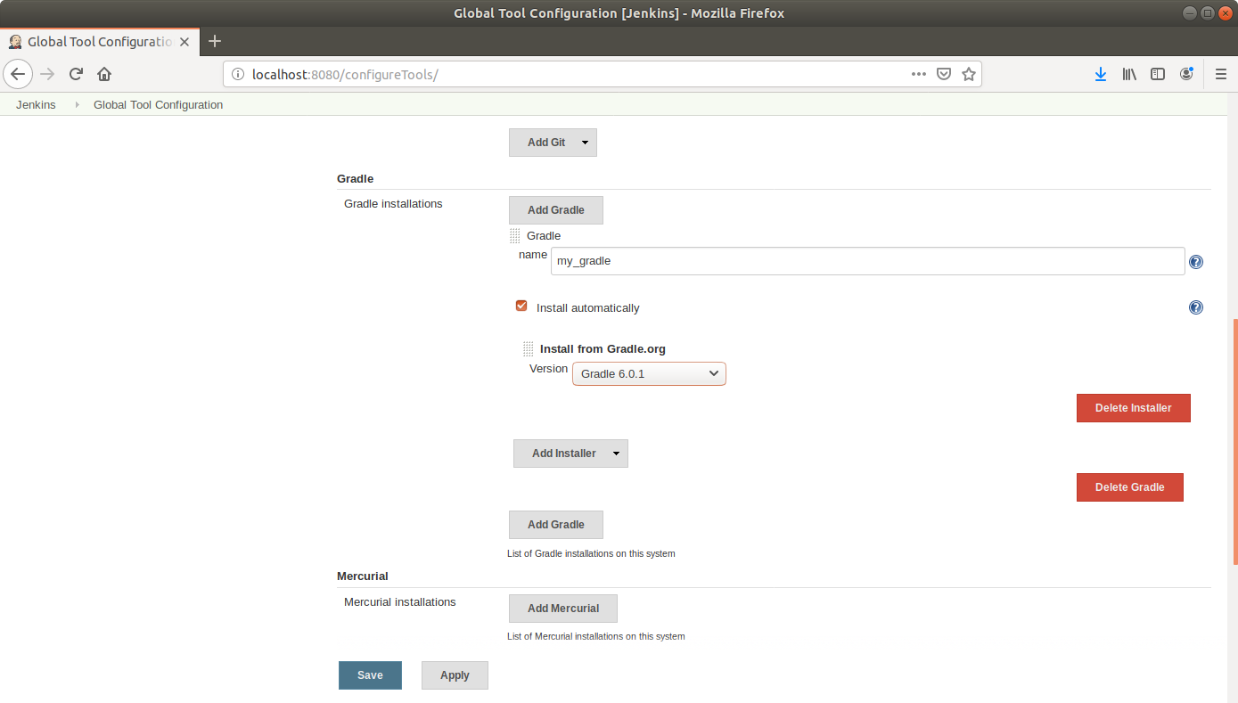

* Click ***Save***.

**Step 2:** Creating a Gradle project

* Open the terminal.
* If you don’t have gradle installed, run **sudo apt-get install gradle** command
* Create a new directory and navigate to it  
  **mkdir gradle-demo   
  cd gradle-demo**
* Run **gradle init** to create a sample gradle project.

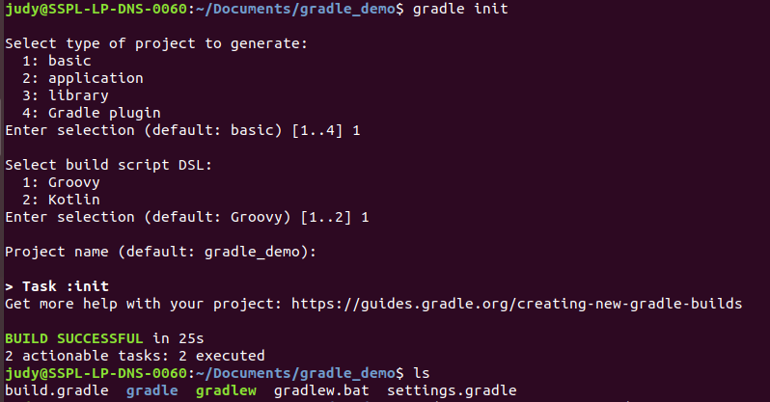

* Go to github.com and create a new repository.

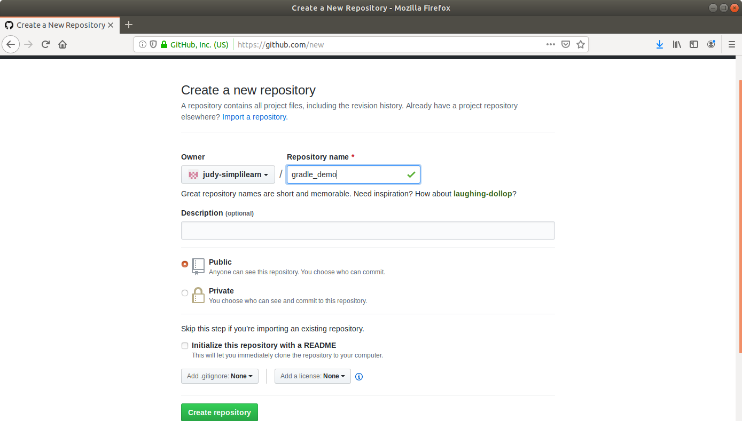

* Push the gradle project to the repository as shown below:  
   **git init**

**git add .**

**git commit -m “First Commit”**

**git remote add origin <your repository URL>**

**git push -u origin master**

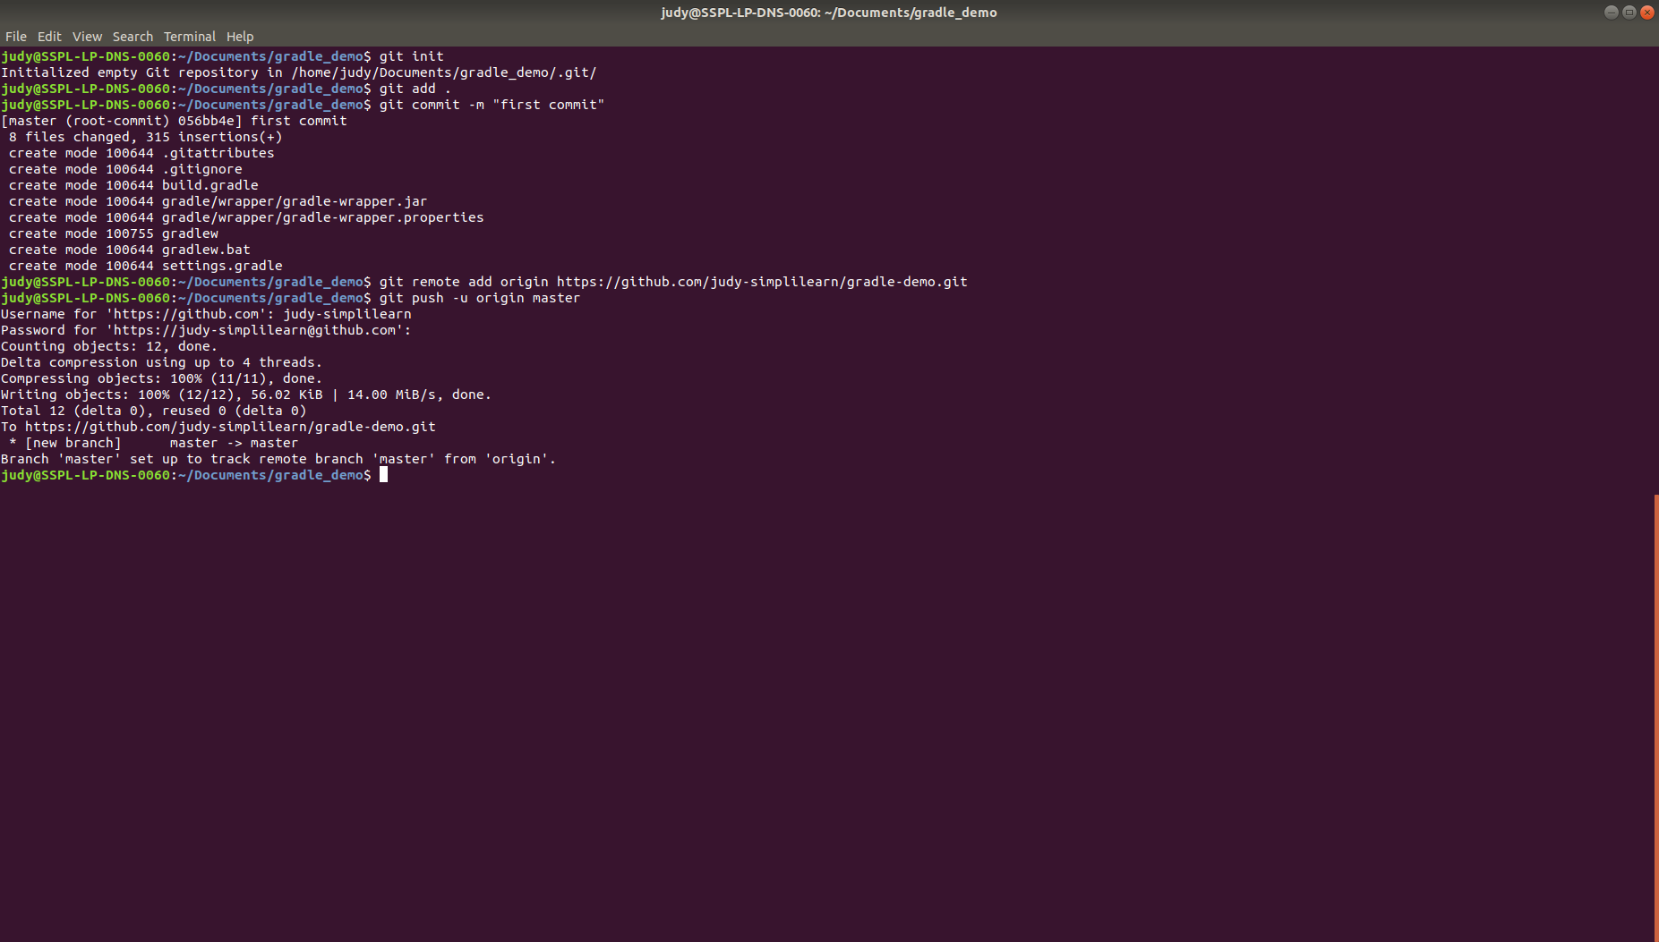

**Step 3:** Building a project with Gradle in Jenkins

* Go to Jenkins dashboard.
* Click on ***New Item***.
* Enter a **name** for your build job.
* Select ***Freestyle project***as the build job type.

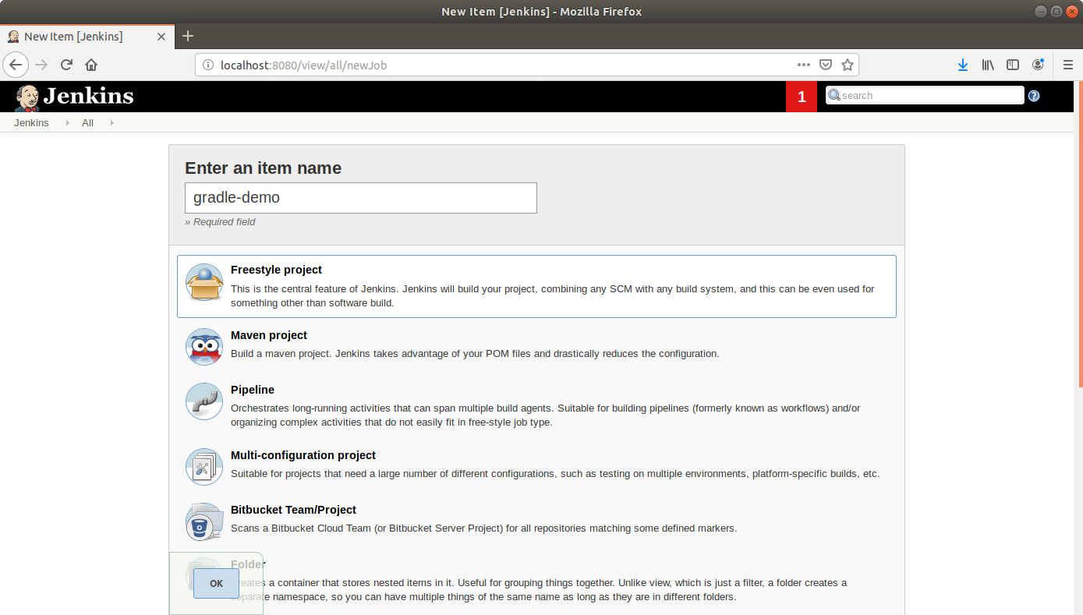

* Click **OK**.
* Scroll down to the Source Code Management section and select ***Git***.
* Enter the link to the repository in the field that appears.

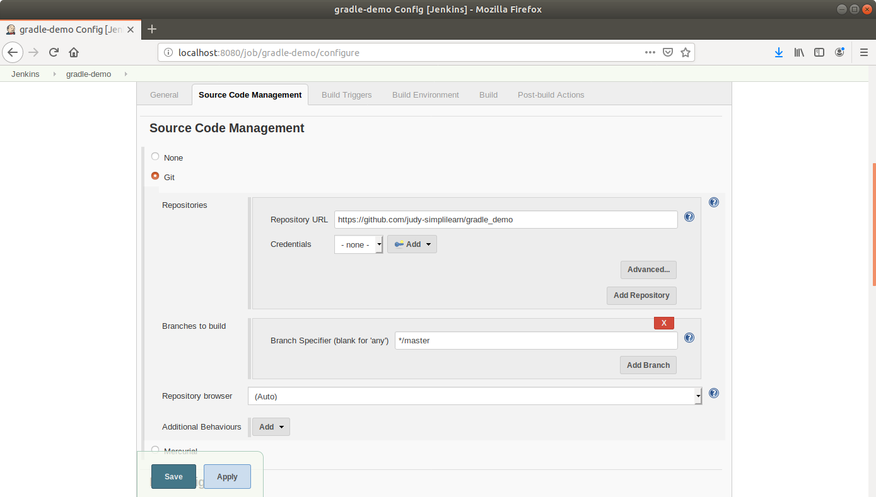

* Scroll down to the***Build*** section and click on ***Add build step***.
* Select***Invoke Gradle Script***from the drop down that appears.
* Fill up the form as shown below:

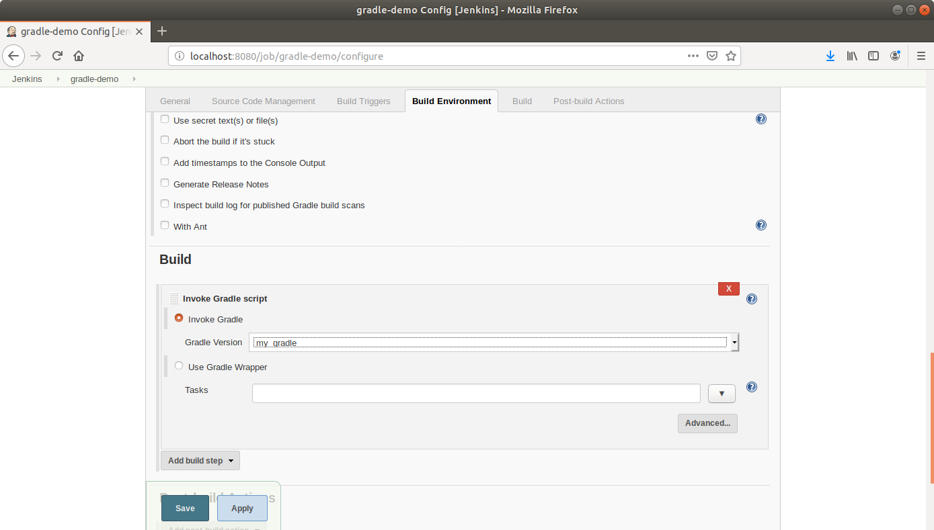

* Scroll down to the ***Post-build Actions*** tab and click on the ***Add post-build action*** button.
* From the drop down, select ***Email notification***and fill the recipient address in the textbox that appears.
* Click **Save**.
* Click ***Build Now*** in the project window to make sure that the build works. Jenkins will now build your project.
* Click on the ***Build History***to view the build results.
* Click on the ***Console Output*** to view the build logs.